GIT HUB ASSIGNMENT

SERCTION 2

22. create an empty directory assignment and cd to assignment

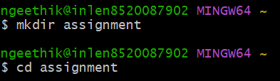

23.Create a file readme.txt inside assignments and add few lines of content of assignment folder

24 commit the readme.txt file

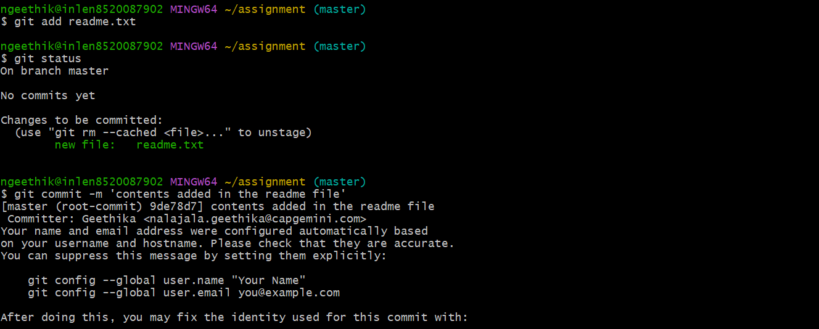

25.Now create a new branch html-assignment



26.Switch to html- assignment branch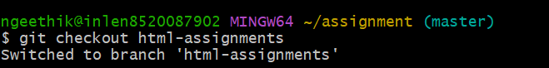

27.Copy all html assignment into html assignment folder



28.commit html assignments into html into html branch

29.make minor changes to few files belonging to html assignments branch

30,commit those changes

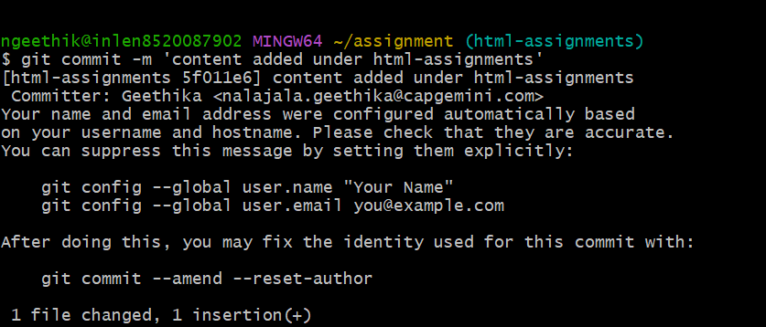

31. Switch to master branch

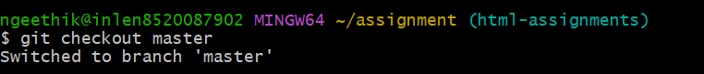

32.make minor changes to readme.txt and commit those changes

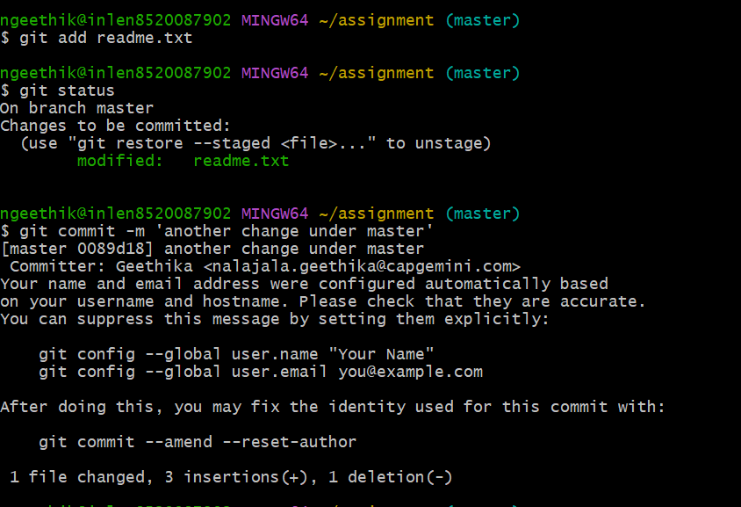

33.Again switch to html-assignments branch

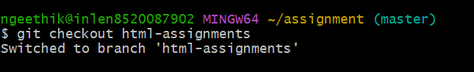

34 make some changes into few files belong to html assignment branch

35.commit those changes

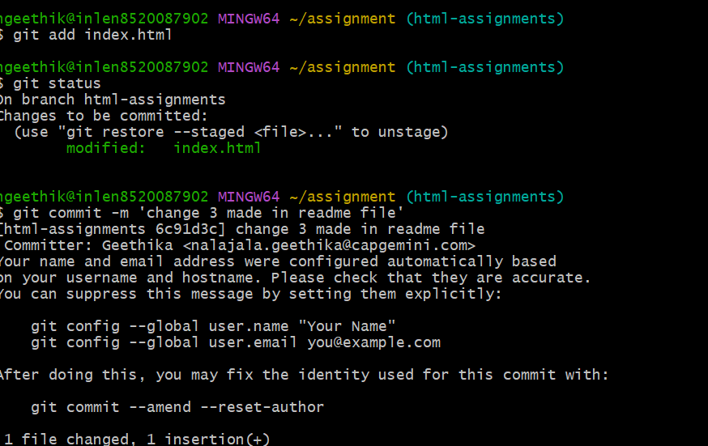

36.switch to master

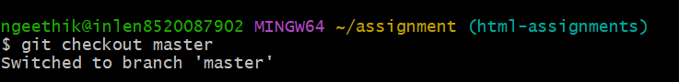

37.merge html assignment branch into master confirm all html assignments are shown in master

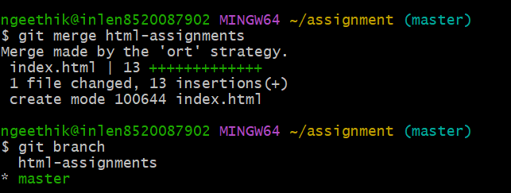

38. finally delete the final assignment branch

